- Create a MUI Radio group 'Gender', with 2 radio buttons respectively for 'Male' & 'Female'
Coding:
import { useState } from "react";
import {
Radio,
RadioGroup,
FormControlLabel,
} from "@mui/material";

function RadioButton() {
const [gender, setGender] = useState("");

return (
<div>
<h3>Gender</h3>

<RadioGroup
value={gender}
onChange={(e) => setGender(e.target.value)}
>
<FormControlLabel
value="Male"
control={<Radio />}
label="Male"
/>

<FormControlLabel
value="Female"
control={<Radio />}
label="Female"
/>
</RadioGroup>
<h1>Gender : {gender}</h1>
</div>
);
}

export default RadioButton;

Output:
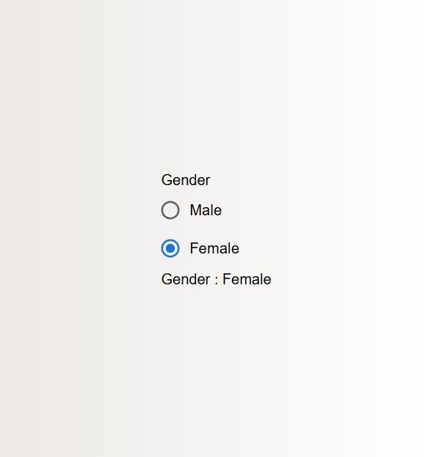
- Create a MUI Switch button to toggle between 'dark' and 'light' mode.
Coding:
import { FormControl, FormControlLabel, Switch, Typography } from "@mui/material";
import { useState } from "react";

function SwitchButton(){
const [dark,setDark] = useState(false)

return(
<>
<div style={{backgroundColor:dark?"black" : "white" , height:"100vh", width:"100vw"}}>
<FormControlLabel control={<Switch onClick={() => setDark(!dark)}/>} sx={{color: dark ? "white" : "black"}} label="Dark Mode">
</FormControlLabel>
<Typography sx={{color: dark ? "white" : "black"}}>
{dark ? "On" : "Off"}
</Typography>
</div>
</>
)
}

export default SwitchButton

Output:
